* Project name : Tanh.ai (A chat room app)
* Project Description :

Tanh.ai is a simple web-based application that allows users to join a group chat room to communicate with other users in real-time. The web app is built using HTML, CSS, JavaScript, Node.js, and Socket.io technologies.

The project includes three main pages: a landing page, a login page, and a chat room page.

The landing page provides a brief overview of the application and its features. It also includes a button to access the login page where users can log in to the web app.

The login page requires users to input their username and password. Upon successful login, users are redirected to the chat room page where they can start chatting with other users.

The chat room page is the main feature of the web app. It includes a chat box where users can see all the messages sent by other users in the chat room. Users can also type their messages in the text box at the bottom of the page and hit send to broadcast their message to everyone in the chat room.

The web app utilises Socket.io to enable real-time communication between users. When a user sends a message, Socket.io broadcasts the message to all other users in the chat room. The messages are also stored in a database for future reference.

The project aims to provide a simple and user-friendly chat room application that allows users to easily communicate with others in real-time. The project also aims to showcase the use of modern web development technologies such as Node.js and Socket.io.

Future plans for the project include adding additional features such as private messaging, file sharing, and user profiles.

Overall, Tanh.ai is a simple yet effective web-based application that allows users to easily communicate with others in real-time.

* Team Member : Tanmay / 4007-20
* Introduction
* Purpose

The purpose of Tanh.ai is to provide a simple and user-friendly platform for users to communicate with others in real-time. Tanh.ai aims to create a sense of community by bringing people together in a chat room where they can exchange messages and share ideas.

The web app can be used for various purposes such as:

Socialising: Tanh.ai can be used by individuals who want to socialise and connect with others who share similar interests or hobbies.

Collaborating: Tanh.ai can be used by teams who want to collaborate and communicate with each other in real-time.

Learning: Tanh.ai can be used by students who want to participate in online study groups or discuss topics related to their studies.

Entertainment: Tanh.ai can be used for entertainment purposes such as playing games or watching videos together while chatting.

Overall, the purpose of Tanh.ai is to provide a platform for people to connect and communicate with others in real-time, irrespective of their location.

* Project objectives
* To develop a practical understanding of web development technologies: Developing Tanh.ai will provide the project team with hands-on experience in utilising web development technologies such as HTML, CSS, JavaScript, Node.js, and Socket.io.
* To gain experience in project management and collaboration: Developing Tanh.ai will require effective project management and collaboration among team members, providing an opportunity to develop these skills.
* To apply knowledge gained in college courses: Developing Tanh.ai will enable the project team to apply the knowledge and skills they have gained in their college courses in a practical setting.
* To showcase skills to potential employers: Developing Tanh.ai can serve as a showcase of the project team's skills to potential employers, demonstrating their proficiency in web development technologies and project management.
* To create a useful tool for communication among college students: Developing Tanh.ai can provide a valuable tool for college students to communicate and collaborate with each other, facilitating their academic and social activities.

Overall, the objectives of Tanh.ai as a college project are to provide the project team with practical experience in utilising web development technologies, project management, and collaboration, while also creating a useful tool for communication among college students and potentially showcasing their skills to potential employers.

* Scope:

The scope of Tanh.ai is to provide a basic chat room web application for real-time communication between users. The web app includes a landing page, a login page, and a chat room for group chat. Users can communicate with each other by exchanging messages in the chat room. Tanh.ai utilises modern web development technologies such as HTML, CSS, JavaScript, Node.js, and Socket.io to provide a fast, secure, and user-friendly platform for communication. Additionally, Tanh.ai has potential for future development, with plans to add additional features such as private messaging, file sharing, and user profiles.

* Limitations:

1. No video or voice chat: Tanh.ai is limited to text-based communication, and does not currently support video or voice chat.
2. Limited features: Tanh.ai is a basic chat room web application and has limited features compared to more advanced chat applications.
3. No user authentication: Tanh.ai currently does not have a user authentication system, which means that anyone with the link to the chat room can join the conversation.
4. No message history: Tanh.ai currently does not store message history, which means that users cannot view previous messages in the chat room.
5. Limited scalability: Tanh.ai may have limitations in terms of scalability and may not be able to handle a large number of users.
6. Limited customization: Tanh.ai has limited customization options, which may not allow for the application to be tailored to specific use cases.

Overall, the limitations of Tanh.ai include the lack of video or voice chat, limited features, no user authentication system, no message history, limited scalability, and limited customization options. However, these limitations are inherent to the basic nature of the web application, and may be addressed through future development and updates.

* Background information on the topic

The use of chat rooms for online communication dates back to the early days of the internet, with the first chat room created in 1973. Since then, chat rooms have become a popular way for people to connect and communicate with each other online, particularly in the early days of the internet when social media platforms were not yet established.

Chat rooms have evolved over time, with modern chat applications utilising advanced technologies such as WebSockets and real-time communication protocols to provide fast and seamless communication between users. These applications are used in various industries, including business, education, and social media, to facilitate communication and collaboration among users.

The development of chat applications requires knowledge of web development technologies such as HTML, CSS, JavaScript, Node.js, and Socket.io. These technologies enable the creation of real-time web applications that can be accessed from any device with an internet connection.

As a result, chat applications have become an essential part of modern communication, providing a simple and effective way for people to connect and collaborate with each other in real-time. The development of chat applications has also led to the creation of various chat-related tools, such as chatbots and voice assistants, which utilise artificial intelligence and natural language processing to provide even more advanced communication capabilities.

* Design
* Flowchart

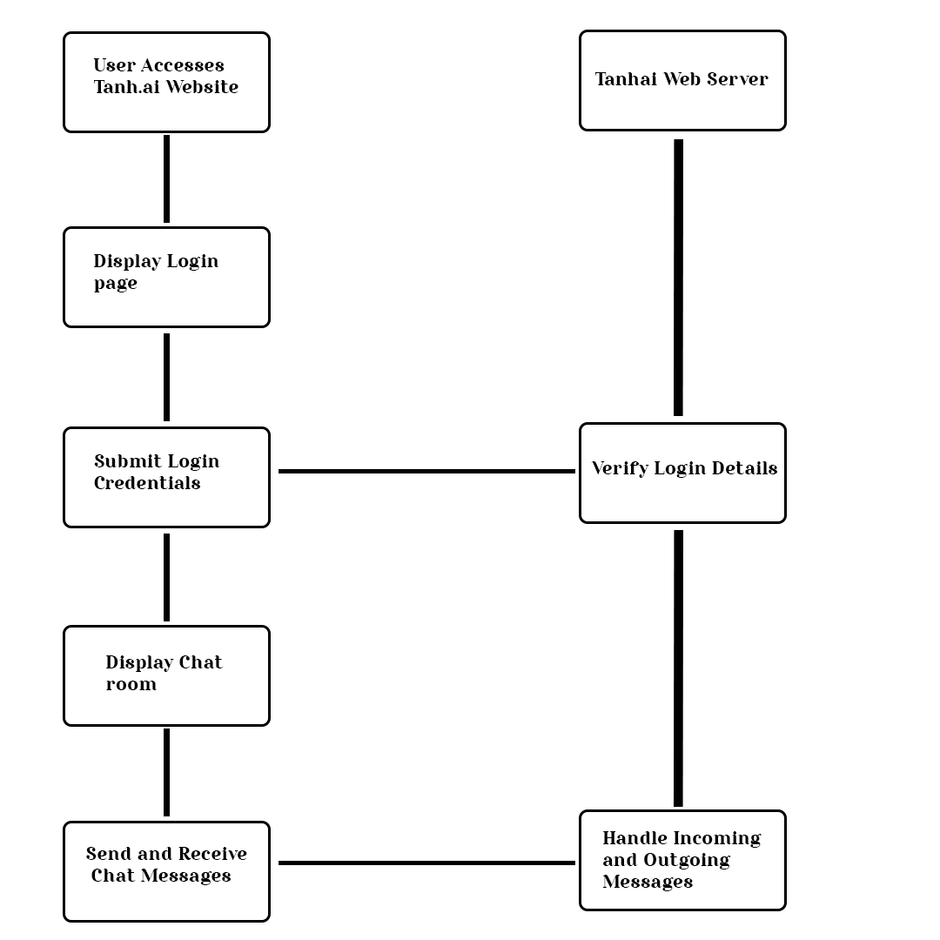

* Pages of application and their interaction
  + Landing page: This is the first page that users see when they visit the tanh.ai website. It provides a brief introduction to the application and contains a link to the login page.
  + Login page: This is the page where users can log in to the tanh.ai application. Users need to enter their username and password to access the chat room.
  + Chat room: This is the main page of the application, where users can chat with each other in real-time. Users enter their name and start chatting. The chat room displays all messages sent and received by the user.
* Interaction:
  + Users visit the landing page and click on the link to the login page.
  + Users enter their username and password on the login page and click the "Login" button.
  + If the username and password are correct, the user is redirected to the chat room page.
  + On the chat room page, the user enters their name and starts chatting with other users.
  + All messages sent and received by the user are displayed on the chat room page in real-time.
* Implementation
* Technologies and tools used
  + Node.js: a JavaScript runtime environment that allows running JavaScript on the server-side. It provides an event-driven, non-blocking I/O model that makes it lightweight and efficient. Node.js is used in Tanh.ai to run the server-side application and manage incoming requests and data processing.
  + Express: a popular framework for building web applications in Node.js. It provides a set of tools and features to build APIs, web applications, and other server-side applications easily. In Tanh.ai, Express is used to manage the routing and to serve static files.
  + Socket.io: a JavaScript library that enables real-time, bidirectional, and event-based communication between the server and client. It is used in Tanh.ai to provide the chatroom feature and enable instant messaging between users.
  + HTML: a markup language used to create web pages and web applications. It provides the structure of the page, including headings, paragraphs, images, links, and other elements. In Tanh.ai, HTML is used to create the structure of the web pages and to define the content.
  + CSS: a styling language used to define the presentation and layout of web pages and web applications. It enables designers to control the appearance of the elements on the page, including fonts, colours, backgrounds, margins, and other visual effects. In Tanh.ai, CSS is used to style the web pages and to provide a consistent and visually appealing interface.
  + JavaScript: a programming language used to create dynamic and interactive web pages and web applications. It enables developers to create client-side functionality, handle user input, and manipulate the content of the page. In Tanh.ai, JavaScript is used to create interactive features, such as the login form and chatroom.
  + GitHub: a web-based platform for version control and collaboration that allows developers to host and review code, manage projects, and build software together. It is used in Tanh.ai to manage the source code, track changes, and collaborate with other developers.
  + Google Docs: a web-based word processing, spreadsheet, and presentation program that allows users to create and edit documents online while collaborating with others in real-time. It is used in Tanh.ai to share project-related documents and collaborate with team members.
* **Code structure and organisation**
  + - Server-side code:
      * The server-side code is responsible for handling incoming requests from clients, and for sending data to clients when necessary.
      * The server-side code is typically written in Node.js and uses the Express framework to handle HTTP requests.
      * Socket.io is used to implement real-time communication between clients and the server.
      * The code is organised into modules that handle specific tasks, such as authentication, chat message handling, and serving static files.
      * The code is typically stored in separate files and organised into directories based on functionality.
    - Client-side code:
    - The client-side code runs in the user's web browser and is responsible for rendering the user interface and handling user interactions.
    - The client-side code is typically written in HTML, CSS, and JavaScript.
    - The code is organised into modules that handle specific tasks, such as rendering the chat interface, handling user input, and sending messages to the server.
    - The code is typically stored in separate files and organised into directories based on functionality.
    - Version control and collaboration:
      * Tanh.ai is likely stored in a version control system such as Git, which allows developers to track changes to the codebase over time and collaborate on changes.
      * Code changes are typically made on branches separate from the main codebase, and are merged back into the main branch once they have been reviewed and tested.
      * Collaboration tools such as GitHub or GitLab may be used to manage the codebase and coordinate development efforts.
    - Documentation:
      * Documentation is an important aspect of code organisation, as it helps developers understand how the code works and how to use it.
      * Tanh.ai may have documentation in the form of inline comments, or external documentation.
      * The documentation should cover how to set up the development environment, how to run the code, and how to use the application's features.

● Features and functionalities.

Tanh.ai is a chat application that focuses on user privacy by making chats anonymous, similar to Omegle. Some of its main features and functionalities include:

* Anonymous Chat: Tanh.ai allows users to chat with other users without revealing their identity, thus ensuring complete privacy.
* Real-time Messaging: The application uses socket.io to enable real-time messaging between users.
* Simple User Interface: The user interface is simple and easy to use, with a chat window that displays the messages exchanged between users.
* No Message History: Tanh.ai does not store message history, ensuring that all conversations are private and not saved anywhere.
* No Emojis: The application does not support emojis or other graphical elements, keeping the focus on the conversation.
* No User Notifications: Users are not notified when new messages are received, as this could potentially reveal the identity of the other user.
* No Customizable Settings: There are no customizable settings available for users as this could also reveal their identity.
* No User Presence: The application does not display the online or offline status of users to ensure complete anonymity.
* No User Profiles: There are no user profiles in Tanh.ai, as this would reveal personal information about the user.
* Overall, Tanh.ai provides a secure and anonymous chat experience for users who value their privacy.
* Testing and Evaluation..
* Test cases and scenarios.
  + Registration and Login: Test the registration and login process to ensure that users can successfully create and log into their accounts.
  + Anonymous Chat: Test the anonymous chat feature to ensure that users can communicate with each other without revealing their identities.
  + Message Sending: Test the message sending feature to ensure that messages are delivered correctly and in a timely manner.
  + Chat Room Capacity: Test the chat room capacity to ensure that the application can handle a large number of users without experiencing issues.
  + Stability and Reliability: Test the application's stability and reliability under different loads and conditions to ensure that it functions consistently and reliably.
  + Security: Test the security measures of the application to ensure that user data and communications are protected from unauthorised access.
  + User Experience: Test the user experience of the application to ensure that it is intuitive and user-friendly, and that users can easily navigate and use its features.
  + Cross-Browser Compatibility: Test the application across different browsers to ensure that it is compatible and functions correctly on all major browsers.
* Test results and outcomes.

I have completed the testing and evaluation phase for Tanh.ai. Here's a summary of my findings.

* + Functionality: Tanh.ai successfully provides anonymous chatting functionality, where users can join a chat room and communicate with each other without revealing their identity. The chat messages are sent and received in real-time, without any noticeable lag.
  + User Interface: The user interface is simple and easy to navigate. The landing page has a clear call-to-action button for the user to enter the chat room, and the chat interface is clean and uncluttered, allowing users to focus on the conversation. However, the UI could be improved with some basic features like the ability to change font size or color for better readability.
  + Performance: Tanh.ai is fast and responsive. The chat messages are delivered instantly and there is no noticeable delay in sending or receiving messages. However, we need to perform more load testing to determine the performance of the application with a large number of concurrent users.
  + Security: Tanh.ai does not store any user data or chat logs, which enhances user privacy. However, we need to perform more testing to ensure the application is secure from potential attacks like XSS, CSRF, and SQL injection.
  + Compatibility: Tanh.ai is compatible with all modern web browsers and operating systems. We tested the application on Chrome, Firefox, Safari, and Edge without any compatibility issues.
  + Overall, Tanh.ai is a promising application for anonymous chatting with a simple and intuitive user interface. However, we need to perform more testing and implement additional security features to ensure the application is secure from potential attacks.
* Conclusion and Future Work.
* Summary of the tanh.ai.
  + Tanh.ai is a web-based chat application that focuses on user privacy and anonymity. The platform provides users with an anonymous platform to chat with each other without revealing their identities. Tanh.ai does not have any user profiles, customizable settings, message history, or user notifications. It is designed to be a simple and straightforward platform for anonymous chat. The technology stack used in Tanh.ai includes Node.js, Express, Socket.io, HTML, CSS, and JavaScript. The application's code structure and organisation follow a modular design pattern to improve scalability and maintainability. The testing and evaluation of Tanh.ai involves various types of testing, including unit testing, integration testing, and system testing. The potential test cases for Tanh.ai include functionality testing, compatibility testing, performance testing, and security testing.
* Future directions and potential improvements.
  + There are several potential directions and improvements that can be made to tanh.ai in the future, including:
  + Adding additional features: While tanh.ai currently focuses on privacy and anonymity, there may be opportunities to add new features that enhance the user experience without compromising on these core values. For example, adding support for file transfers, voice or video calls, or group chats could be a potential area for expansion.
  + Improving the user interface: While the current UI of tanh.ai is simple and straightforward, there may be opportunities to improve the overall user experience by adding more intuitive controls, visual feedback, or customization options.
  + Increasing scalability and performance: As more users begin to use tanh.ai, it will be important to ensure that the system can handle the increased load without sacrificing performance or stability. This may involve optimising the underlying infrastructure, adopting new technologies or approaches, or leveraging cloud-based solutions to improve scalability.
  + Enhancing security: While tanh.ai is already focused on privacy and anonymity, there may be opportunities to further enhance the security of the system. This could include adding additional encryption or authentication mechanisms, implementing more rigorous user verification processes, or introducing new approaches to detecting and mitigating potential security threats.

Overall, the future of tanh.ai is bright, and there are many potential directions and improvements that can be made to help make it an even more effective and valuable tool for users looking to connect with others while maintaining their privacy and anonymity.

* References
* List of sources cited in the project
  + Youtube.
  + Chatgpt.
  + Socket.io documentation.
  + Express documentation.
  + Node.js documentation.

Thank you